**5 PÁGINAS CON OPERADORES**

<https://www.google.com.mx/search?ei=DziHWumsLceYtgXOkoCwBA&q=define%3Arobot&oq=define%3Arobot&gs_l=psy-ab.3...3909.3909.0.4084.1.1.0.0.0.0.64.64.1.1.0....0...1c.1.64.psy-ab..0.0.0....0.w-spBLGCWrg>

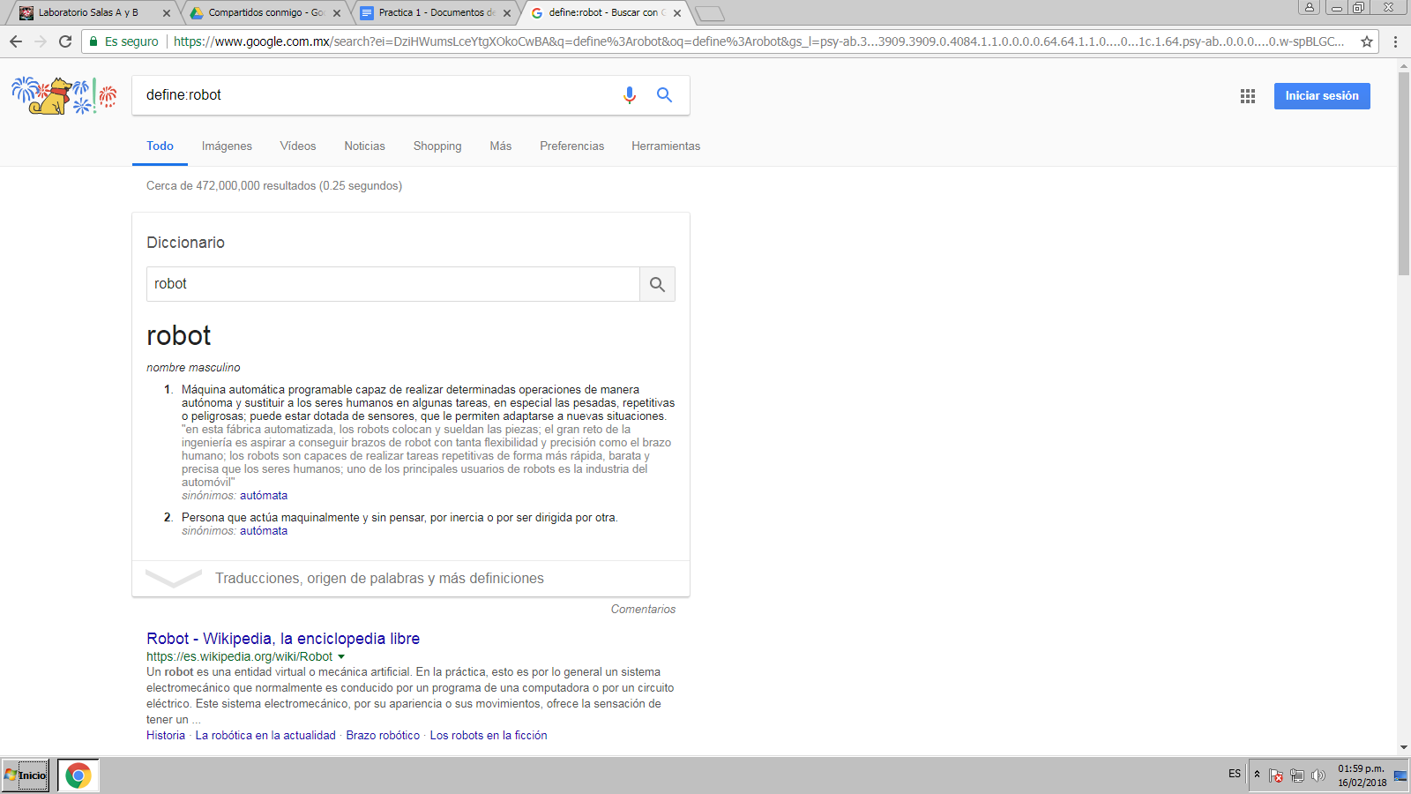

<https://scholar.google.com.mx/scholar?q=intitle:Medicina+intext:avances+filetype:pdf&hl=es&as_sdt=0,5>

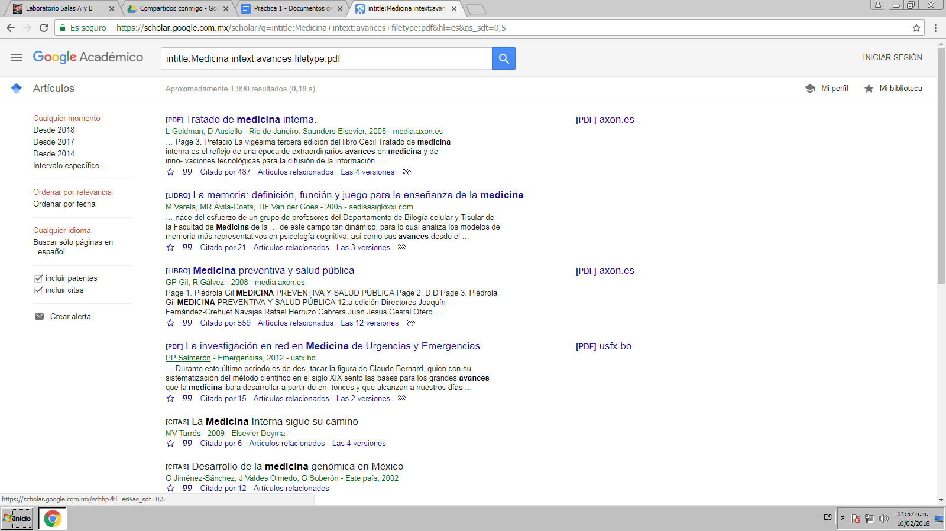

<https://scholar.google.com.mx/scholar?hl=es&as_sdt=0,5&q=%22organos+artificiales%22>

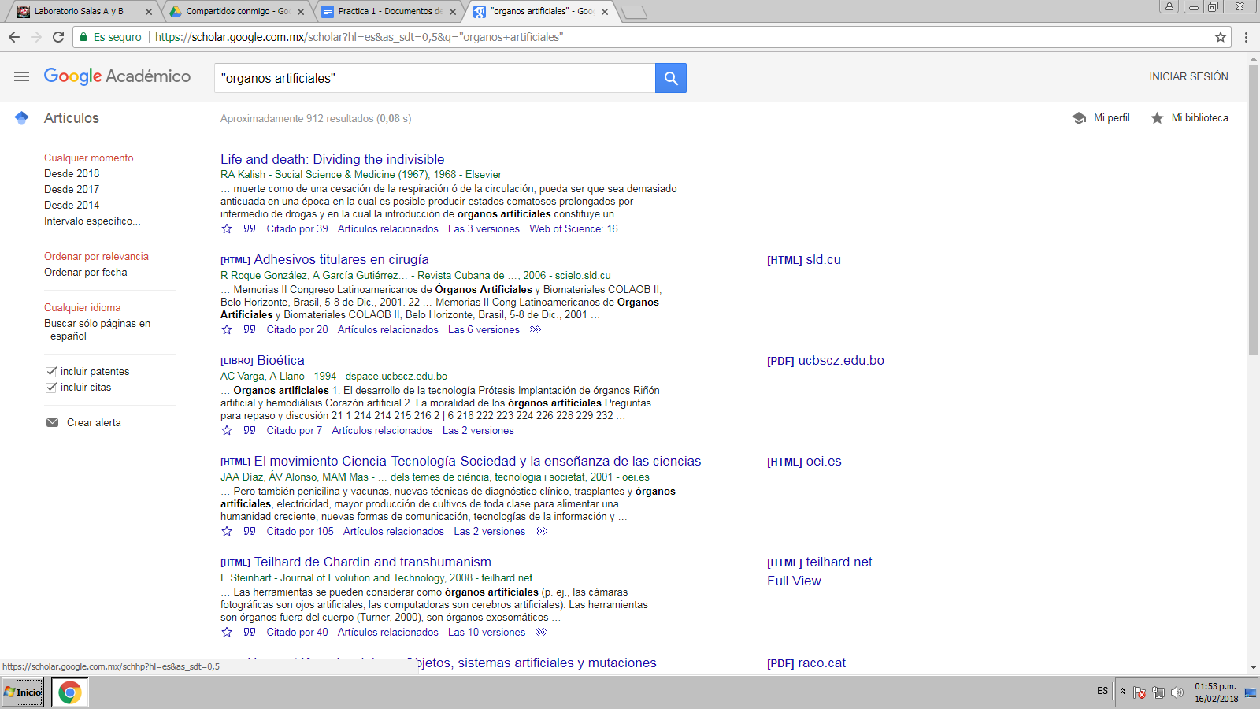

<https://www.google.com.mx/search?num=50&safe=active&ei=sDWHWqrcL4OUtQWKwoGACw&q=site%3Anationalgeographic.com+%2B+mexico&oq=site%3Anationalgeographic.com+%2B+mexico&gs_l=psy-ab.3...1470.5214.0.5463.9.9.0.0.0.0.193.712.8j1.9.0....0...1c.1.64.psy-ab..0.0.0....0.y5-ZIED9Jh8>

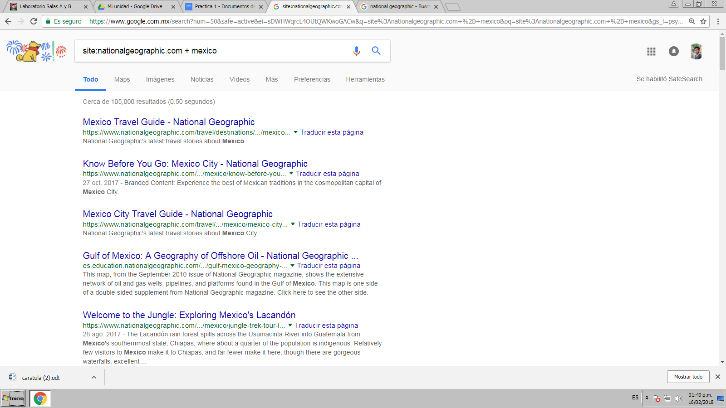

<https://www.google.com.mx/search?dcr=0&ei=xDWHWvP7MIG2tQXG06-oBQ&q=UNAM+2000..2001&oq=UNAM+2000..2001&gs_l=psy-ab.3..38l5.5208.11568.0.12304.4.3.1.0.0.0.127.262.2j1.3.0....0...1c.1.64.psy-ab..0.4.265....0.tLR2PI7HCKs>

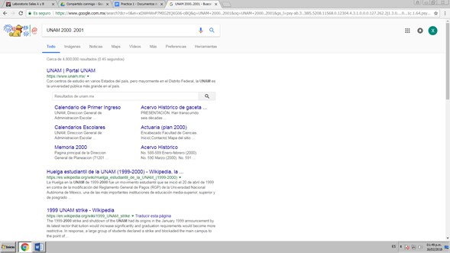

**5 CÁLCULOS CON CALCULADORA**

<https://www.google.com.mx/search?q=calculadora&spell=1&sa=X&ved=0ahUKEwiTr4i1mKvZAhVPC6wKHZfkDo8QBQgkKAA&biw=1600&bih=790>

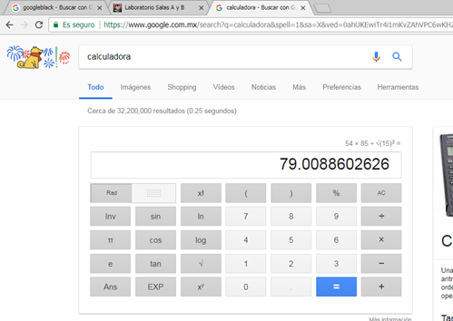

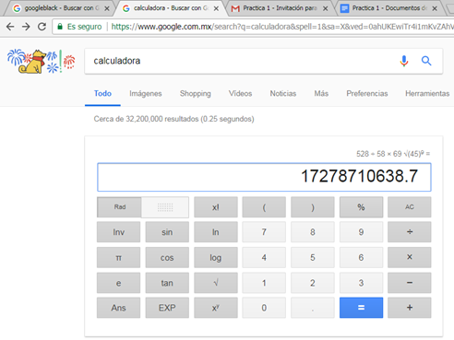

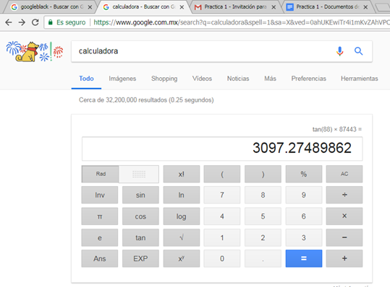

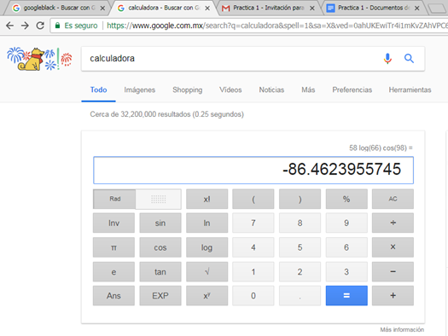

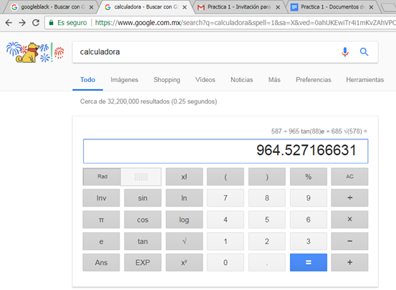

**5 CONVERSIONES DE UNIDADES**

<https://www.google.com.mx/search?dcr=0&ei=0jWHWuXaBIfYtQWE9br4CQ&q=convertir+500+newtons+a+poundals&oq=convertir+500+newtons+a+poundals&gs_l=psy-ab.3..33i22i29i30k1.156936.214352.0.214527.70.50.20.0.0.0.140.3659.47j2.50.0....0...1c.1.64.psy-ab..0.67.3593.6..0j35i39k1j0i131k1j0i67k1j0i10i67k1j0i131i67k1j0i22i10i30k1j0i22i30k1j33i160k1j33i21k1.75.pZjshOy_Dsw>

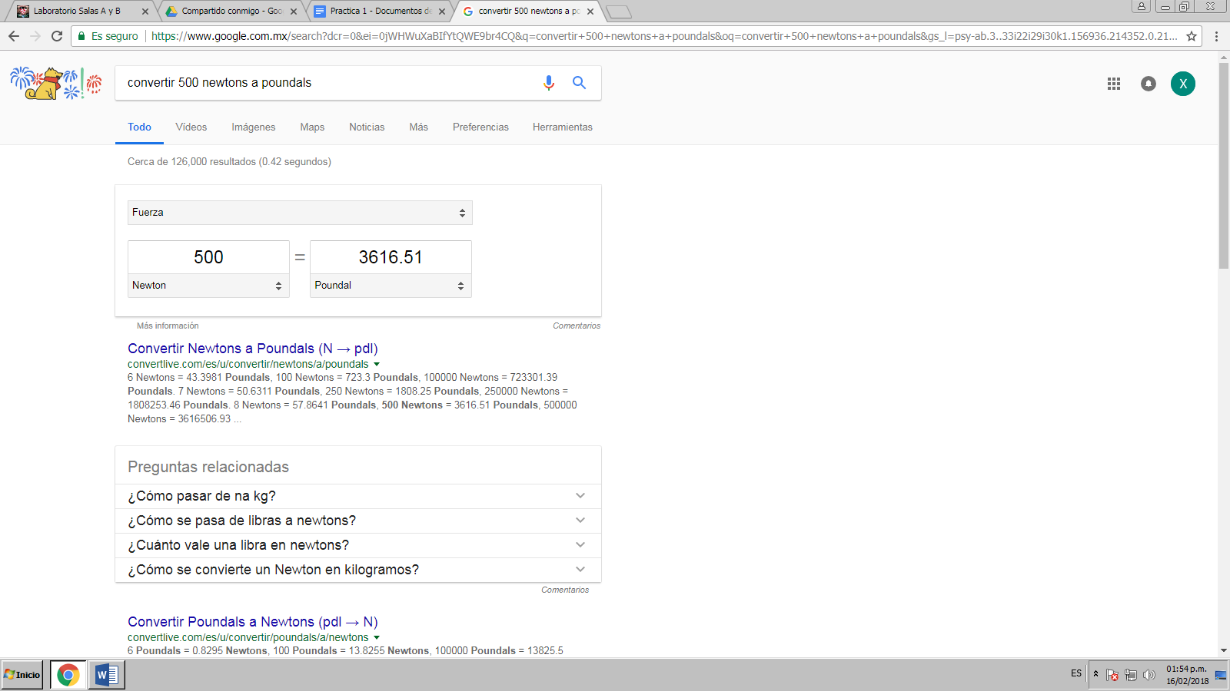

<https://www.google.com.mx/search?dcr=0&biw=1600&bih=790&ei=ojeHWoayGsuItQWSmLawCg&q=convertir+de+75+hp+a+watts&oq=convertir+de+75+hp+a+watts&gs_l=psy-ab.3...3340.3611.0.4810.3.3.0.0.0.0.71.194.3.3.0....0...1c.1.64.psy-ab..0.0.0....0.L4R9DiR6ijQ>

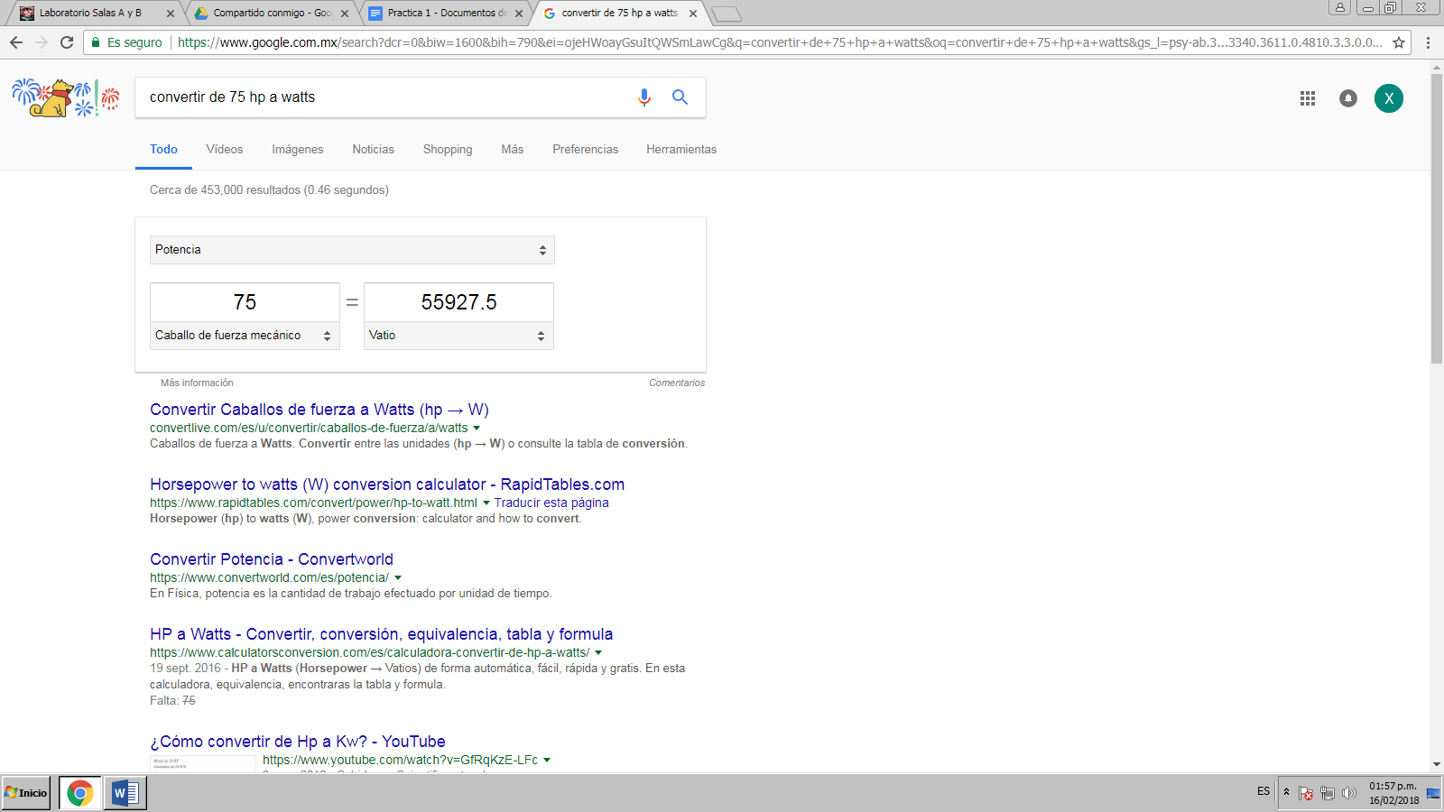

<https://www.google.com.mx/search?dcr=0&biw=1600&bih=790&ei=pzeHWu3FNoWSsAX5hoTgBA&q=convertir+10234+joules+a+calorias&oq=convertir+10234+joules+a+calorias&gs_l=psy-ab.3...42171.95681.0.95793.33.33.0.0.0.0.108.2462.32j1.33.0....0...1c.1.64.psy-ab..0.25.1846...0j35i39k1j0i67k1j0i131k1j0i131i67k1j0i20i263k1j0i22i30k1j33i160k1j33i21k1.0.BWgschX1PNc>

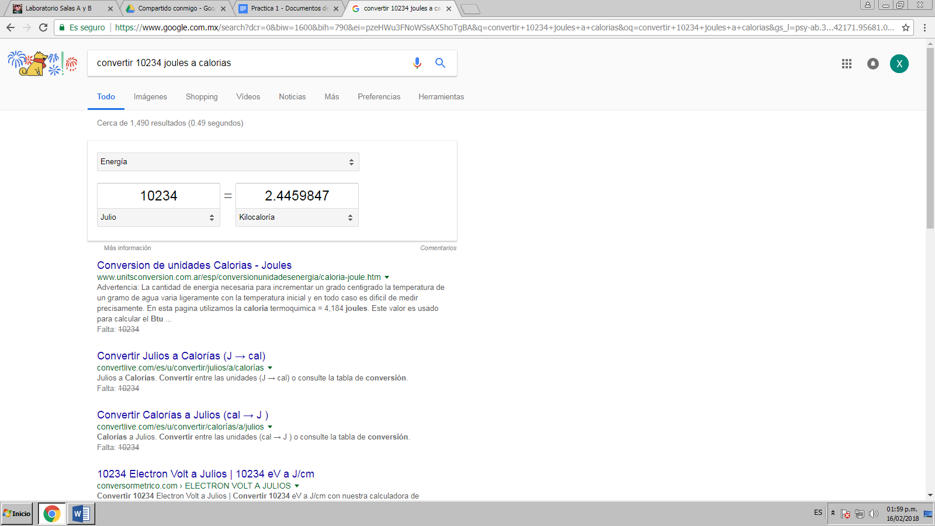

<https://www.google.com.mx/search?ei=WTiHWsflDMTAsQXV657oAg&q=convertir+50+rankine+a+grados+centr%C3%ADgrados&oq=convertir+50+rankine+a+grados+centr%C3%ADgrados&gs_l=psy-ab.3..33i22i29i30k1l3.961.4159.0.4319.15.15.0.0.0.0.106.1251.14j1.15.0....0...1c.1.64.psy-ab..0.10.843...33i160k1.0.jLgjO0ONY4I>

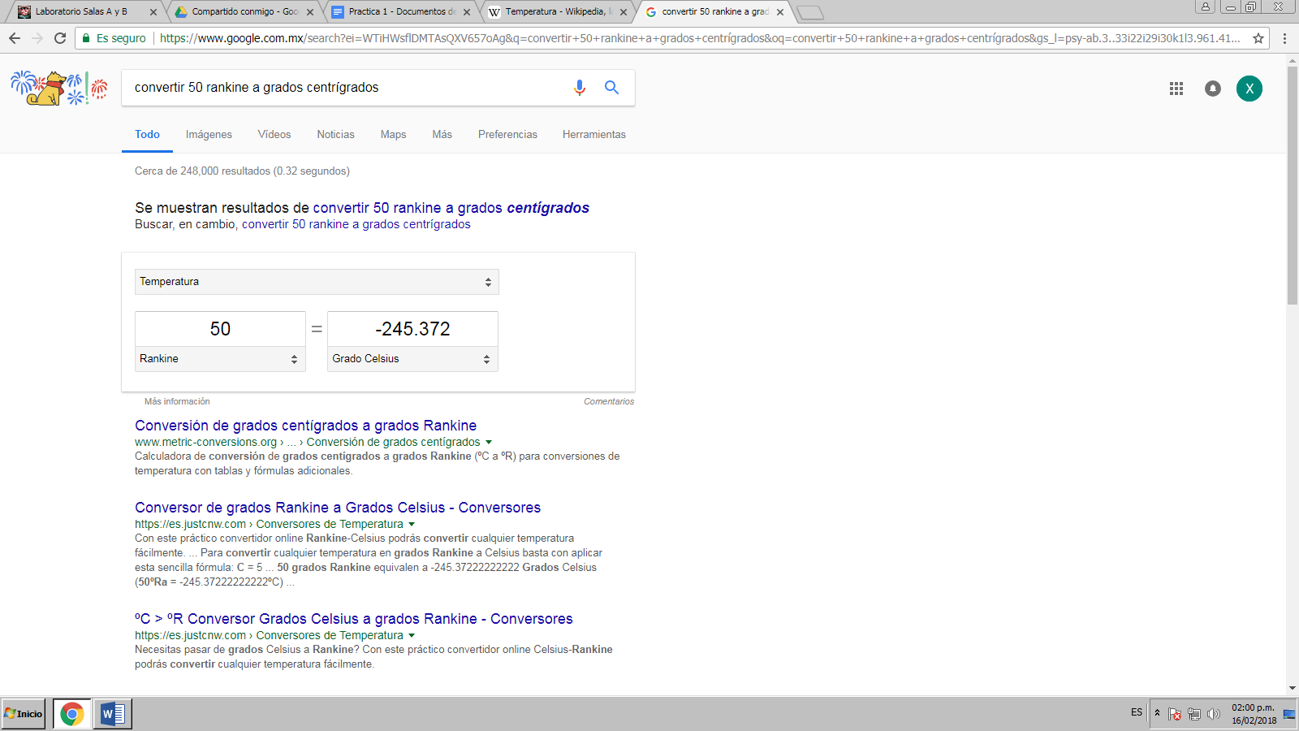

<https://www.google.com.mx/search?q=convertir+218+libras+a+kilogramos&oq=convertir+218+libras+a+kilogramos&aqs=chrome..69i57j0.23808j0j4&sourceid=chrome&ie=UTF-8>

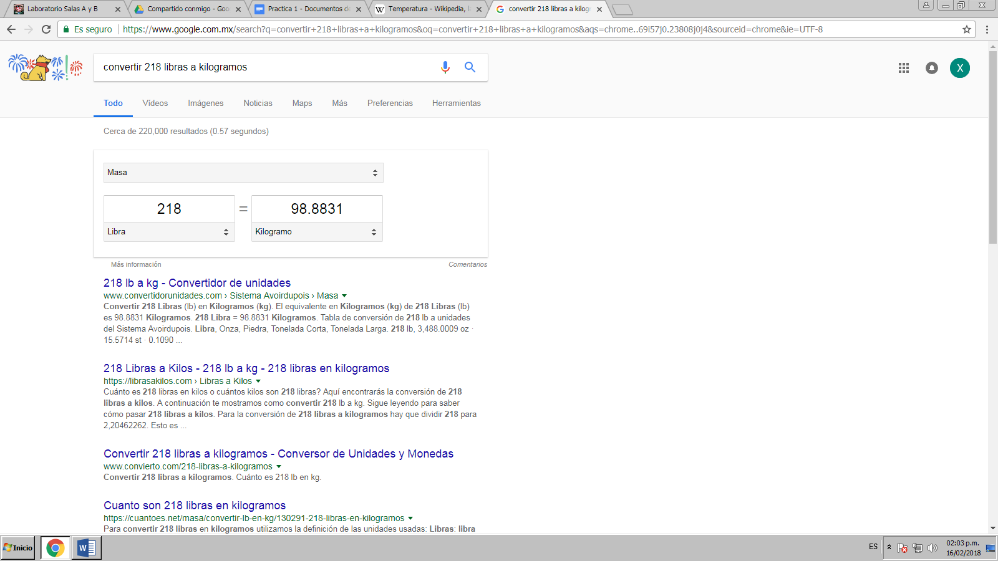

**GRÁFICA 2D**

**Valle Lezama Jorge Alberto**

<https://www.google.com.mx/search?num=50&safe=active&ei=UziHWprfFcrcswWjobqgAQ&q=sinh%28x%29+from+-2pi+to+2pi&oq=sinh%28x%29+from+-2pi+to+2pi&gs_l=psy-ab.3...4943.6048.0.6389.2.2.0.0.0.0.65.128.2.2.0....0...1c.1.64.psy-ab..0.0.0....0.pyNbg6i3rRs>

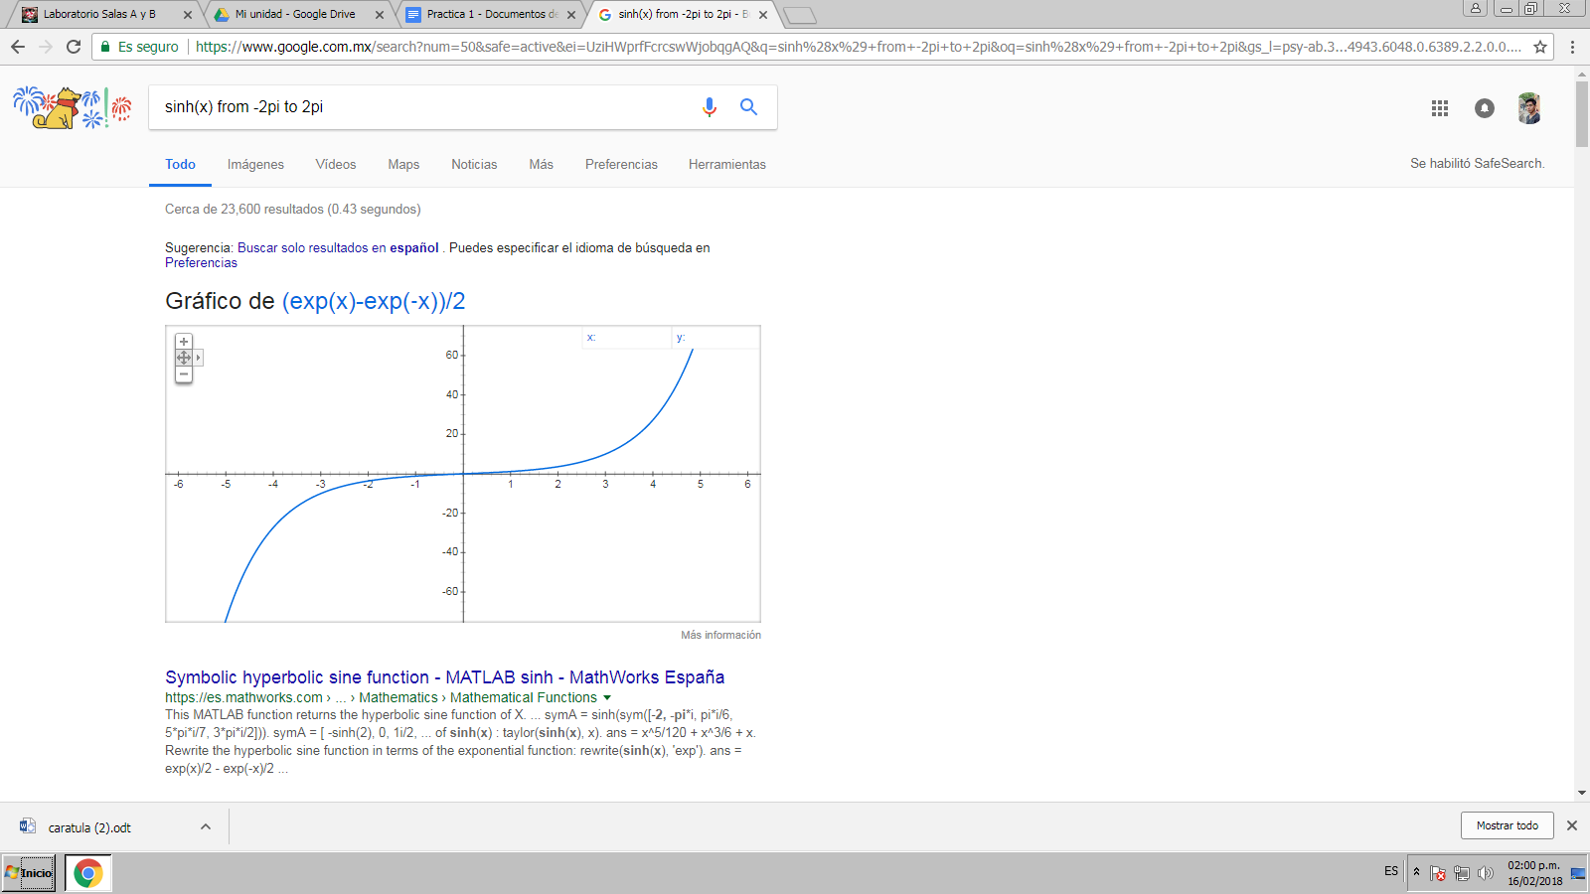

**GRÁFICA 3D**

**Valle Lezama Jorge Alberto**

[https://www.google.com.mx/search?num=50&safe=active&ei=bD2HWpvHKca4sQX0np3AAQ&q=2*%28x**2%2By**2%29*exp%28-x**2-y**2%29&oq=2*%28x**2%2By**2%29*exp%28-x**2-y**2%29&gs_l=psy-ab.3..35i39k1j0i8i30k1j0i8i10i30k1l2j0i8i30k1l6.746.746.0.975.1.1.0.0.0.0.90.90.1.1.0....0...1c.1.64.psy-ab..0.1.90....0.ukO4eNHbEV4](https://www.google.com.mx/search?num=50&safe=active&ei=bD2HWpvHKca4sQX0np3AAQ&q=2*%28x**2%2By**2%29*exp%28-x**2-y**2%29&oq=2*%28x**2%2By**2%29*exp%28-x**2-y**2%29&gs_l=psy-ab.3..35i39k1j0i8i30k1j0i8i10i30k1l2j0i8i30k1l6.746.746.0.975.1.1.0.0.0.0.90.90.1.1.0....0...1c.1.64.psy-ab..0.1.90....0.ukO4eNHbEV4)

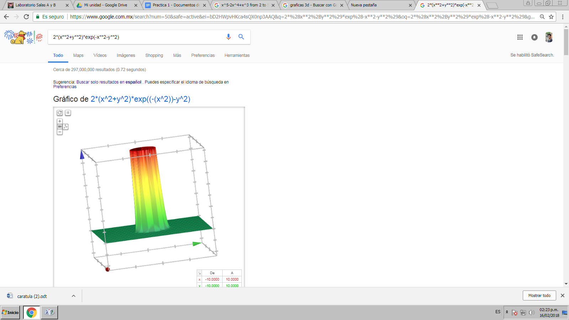

Busqueda por imagen

Valle Lezama Jorge Alberto

<https://www.google.com.mx/search?tbs=sbi:AMhZZitCC74EjN2XEFWkpnmTj7tl37r2onim7Ga5DjIiEYZA0nvU5DSxBVra3fFCea7fn9Y18fu8kwtOl4RrG6BwOWueNHNpdy8cn-i8lxlKm8LGgRJlPfG-9a710PQ16TBAenADFVuRaBg-fRwWbCSpNazzVm0c8xVNsb3Z9LkAcCV8TQUlAx7aLB3UI3NVVjRJ3sdneBxMgHM3Id4H578X1-4oQ2wi9q2fJCTcPjlA7PVV1GYCqTkKqziXoE1pLix-daRc570kUedGeUUZ7oGyIVYc8VXIa4IErXvZm6bVC8eZU3AU82SfBLlDSBTaN7FYIkUKLRgVQxVa-HRUaYSgMoIkTUbCHA&hl=es-419>

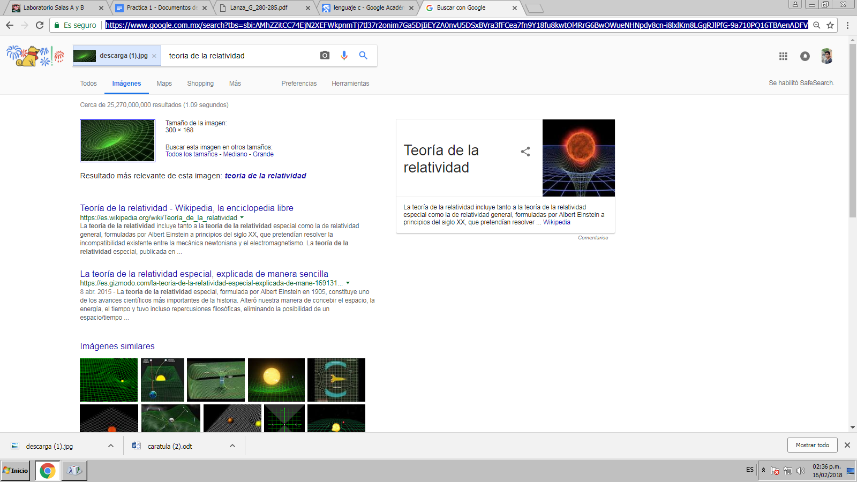

Gonzalez Cabrera Rodolfo

[https://www.google.com.mx/search?ei=yTmHWozCEovIsQWiop-QDw&q=sin+3x%2Fx*2&oq=sin+3x%2Fx*2&gs_l=psy-ab.3..0i22i30k1j0i22i10i30k1j0i22i30k1j0i22i10i30k1j0i22i30k1j0i22i10i30k1j0i22i30k1j0i22i10i30k1j0i22i30k1l2.9564.20955.0.24698.9.7.2.0.0.0.88.587.7.7.0....0...1c.1.64.psy-ab..0.9.590...0j0i67k1j0i7i30k1j0i7i10i30k1j0i19k1j0i22i30i19k1j0i22i10i30i19k1.0.5OAmFZxhiCo](https://www.google.com.mx/search?ei=yTmHWozCEovIsQWiop-QDw&q=sin+3x%2Fx*2&oq=sin+3x%2Fx*2&gs_l=psy-ab.3..0i22i30k1j0i22i10i30k1j0i22i30k1j0i22i10i30k1j0i22i30k1j0i22i10i30k1j0i22i30k1j0i22i10i30k1j0i22i30k1l2.9564.20955.0.24698.9.7.2.0.0.0.88.587.7.7.0....0...1c.1.64.psy-ab..0.9.590...0j0i67k1j0i7i30k1j0i7i10i30k1j0i19k1j0i22i30i19k1j0i22i10i30i19k1.0.5OAmFZxhiCo)

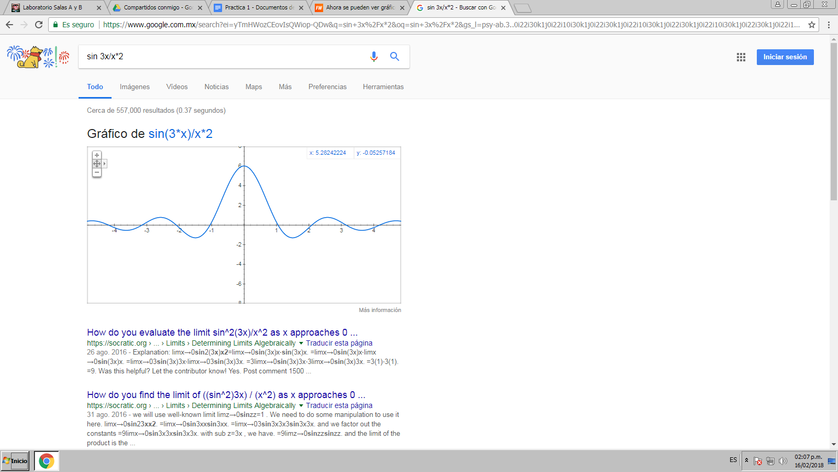

[https://www.google.com.mx/search?q=sin(5.5x)*cos(5*y)%2Bx*x%2B1&oq=sin(5.5x)cos5y%2Bx&aqs=chrome.1.69i57j0.34019j0j8&sourceid=chrome&ie=UTF-8](https://www.google.com.mx/search?q=sin(5.5x)*cos(5*y)%2Bx*x%2B1&oq=sin(5.5x)cos5y%2Bx&aqs=chrome.1.69i57j0.34019j0j8&sourceid=chrome&ie=UTF-8)

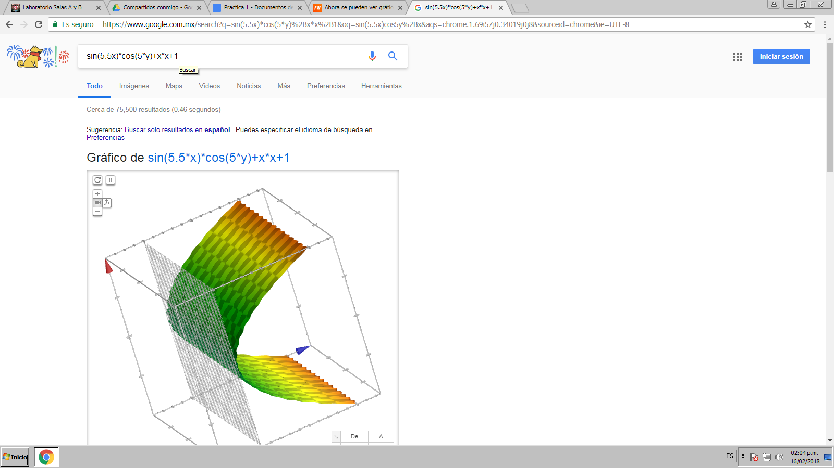

**Grafica 2D Gonzalez Castillo Yael Adair**

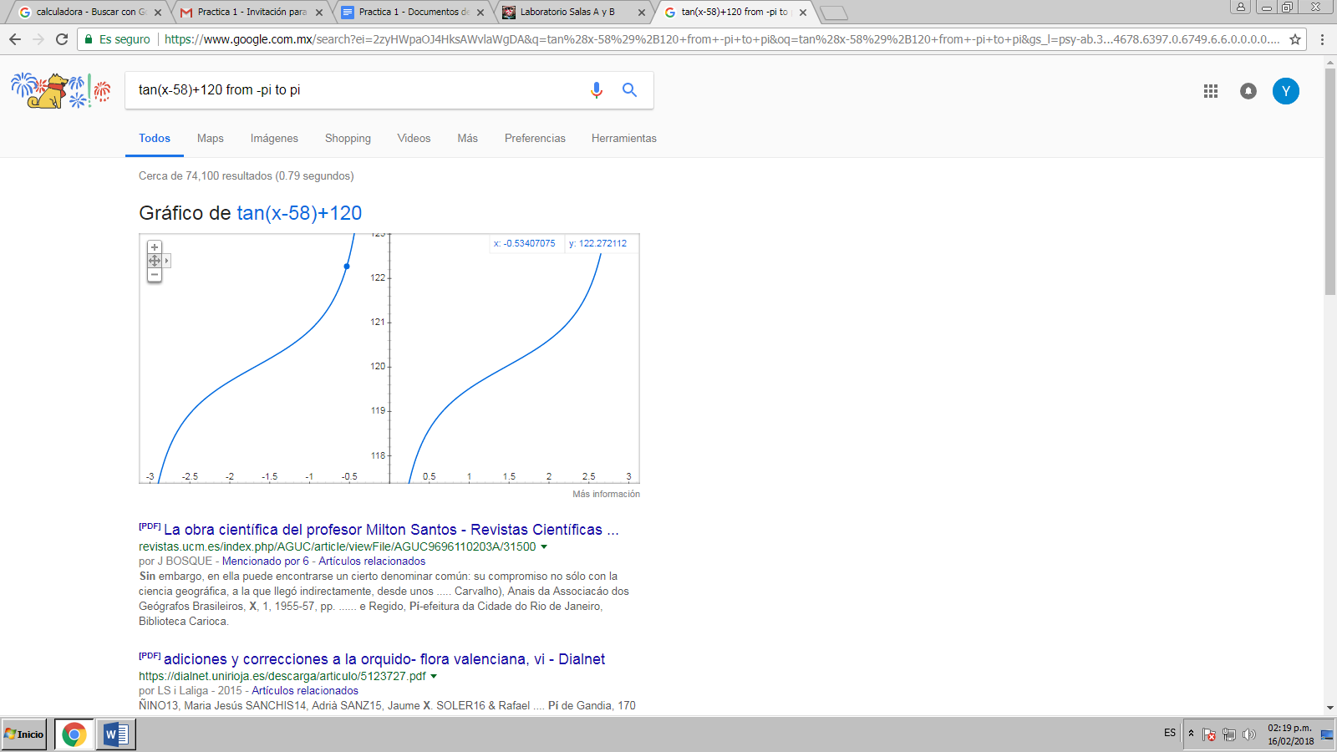

<https://www.google.com.mx/search?ei=2zyHWpaOJ4HksAWvlaWgDA&q=tan%28x-58%29%2B120+from+-pi+to+pi&oq=tan%28x-58%29%2B120+from+-pi+to+pi&gs_l=psy-ab.3...4678.6397.0.6749.6.6.0.0.0.0.66.360.6.6.0....0...1c.1.64.psy-ab..0.0.0....0.VEd3icsVOwg>

**Grafica 3D Gonzalez Castillo Yael Adair**

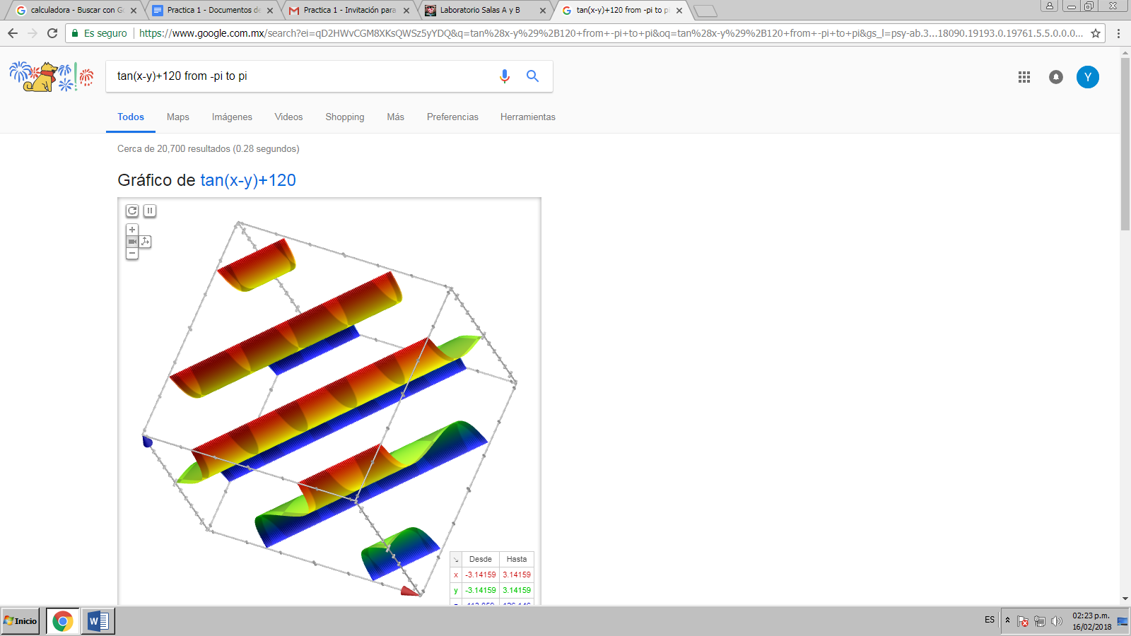

<https://www.google.com.mx/search?ei=qD2HWvCGM8XKsQWSz5yYDQ&q=tan%28x-y%29%2B120+from+-pi+to+pi&oq=tan%28x-y%29%2B120+from+-pi+to+pi&gs_l=psy-ab.3...18090.19193.0.19761.5.5.0.0.0.0.68.303.5.5.0....0...1c.1.64.psy-ab..0.0.0....0.3TvxwcmvX3M>

**GRÁFICA 2D ANAYA RODRÍGUEZ XIMENA**

[https://www.google.com.mx/search?ei=7T6HWtDhGoWasQX7pJmACQ&q=y%3Dx%2F9%2Bx%5E5-x%2Bx%5E150&oq=y%3Dx%2F9%2Bx%5E5-x%2Bx%5E150&gs_l=psy-ab.3...2904.2904.0.3310.1.1.0.0.0.0.87.87.1.1.0....0...1c.1.64.psy-ab..0.0.0....0.6joG4IXu](https://www.google.com.mx/search?ei=7T6HWtDhGoWasQX7pJmACQ&q=y%3Dx%2F9%2Bx%5E5-x%2Bx%5E150&oq=y%3Dx%2F9%2Bx%5E5-x%2Bx%5E150&gs_l=psy-ab.3...2904.2904.0.3310.1.1.0.0.0.0.87.87.1.1.0....0...1c.1.64.psy-ab..0.0.0....0.6joG4IXuitU)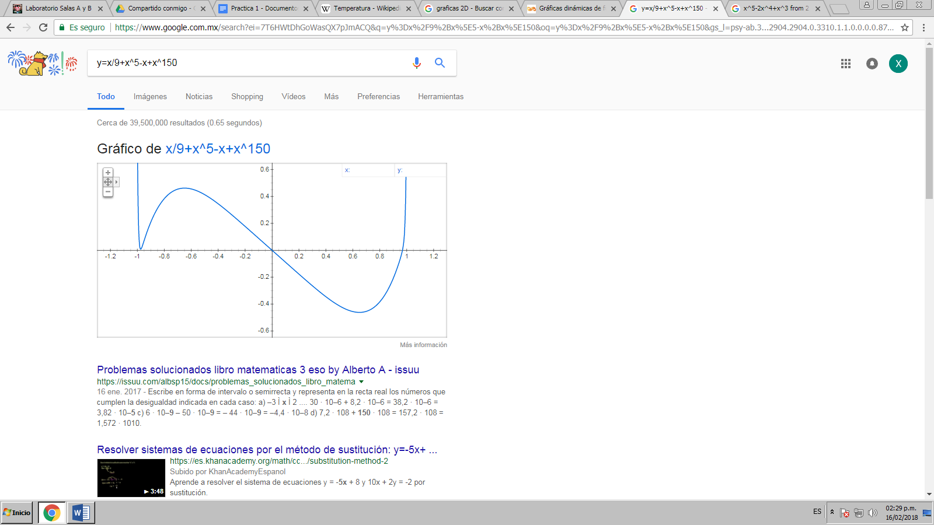

**GRÁFICA 3D ANAYA RODRÍGUEZ XIMENA**

<https://www.google.com.mx/search?biw=1600&bih=790&ei=00OHWs_gK8H0swXVpJfQDg&q=x%5E2-y%5E2&oq=x%5E2-y%5E2&gs_l=psy-ab.3..0l7j0i203k1l2j0.4114.30457.0.30690.20.18.1.1.1.0.114.1497.17j1.18.0....0...1c.1.64.psy-ab..0.16.1179...0i8i10i30k1j0i8i7i10i30k1j0i8i30k1j0i8i7i30k1j0i10i30k1j0i30k1.0.gFnaZieH-xg>

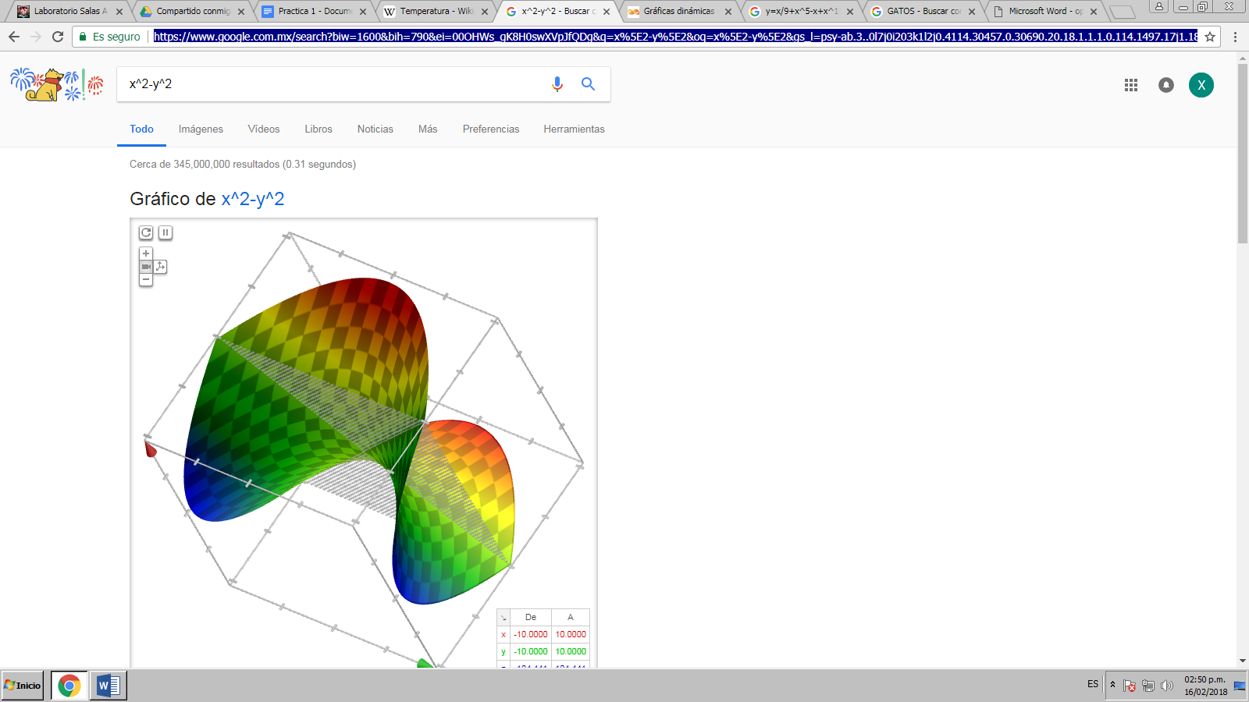

**5 Algoritmos**

<https://books.google.com.mx/books?hl=es&lr=&id=gUE6uxbSk-cC&oi=fnd&pg=PR7&dq=+algoritmos+computacionales&ots=RwKDG5WEru&sig=yFk1_q9P0yyotUAq3L3NeZsQzB8#v=onepage&q=algoritmos%20computacionales&f=false>

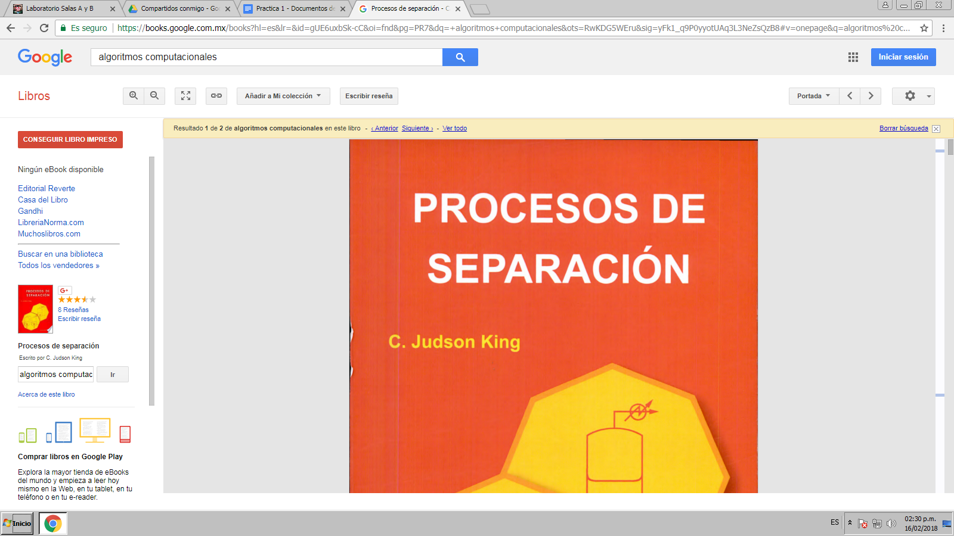

<http://revistas.um.es/red/article/view/240311>

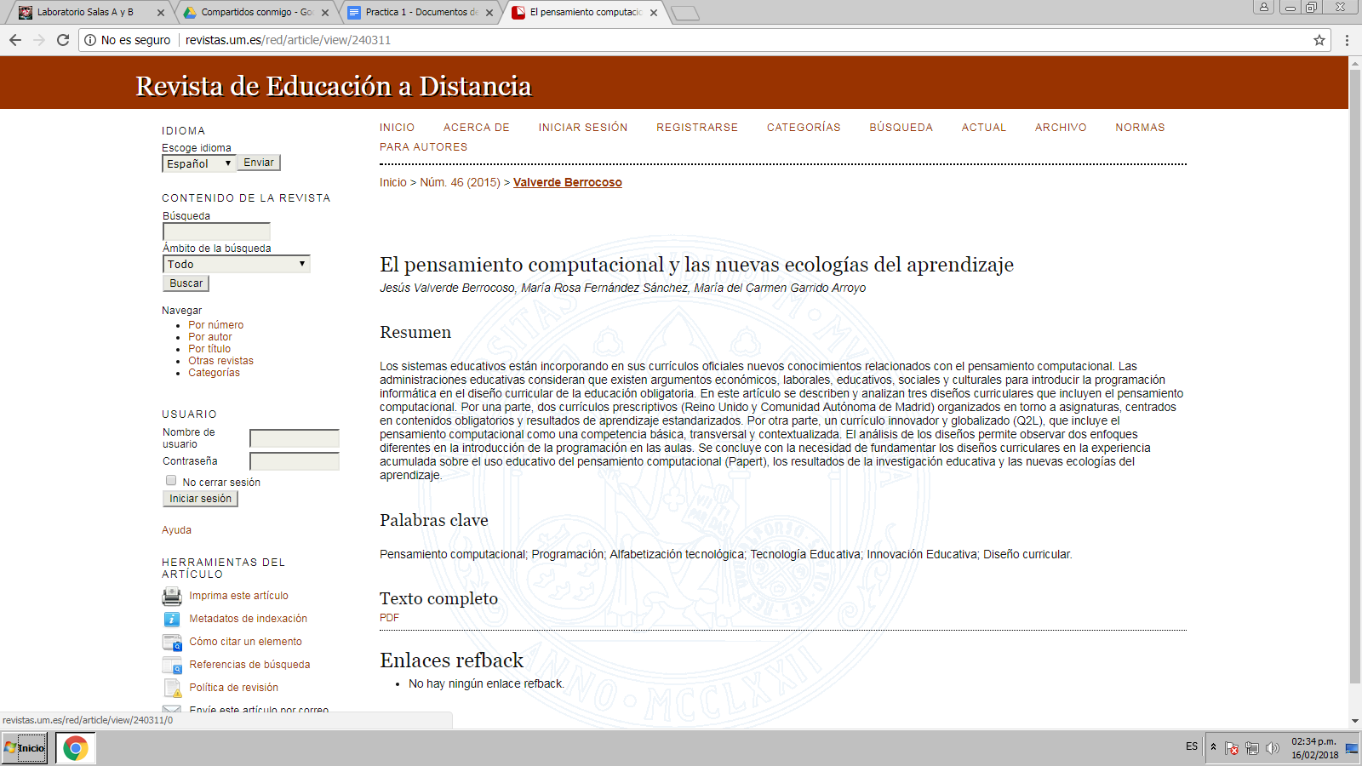

<http://www.redalyc.org/html/730/73000115/>

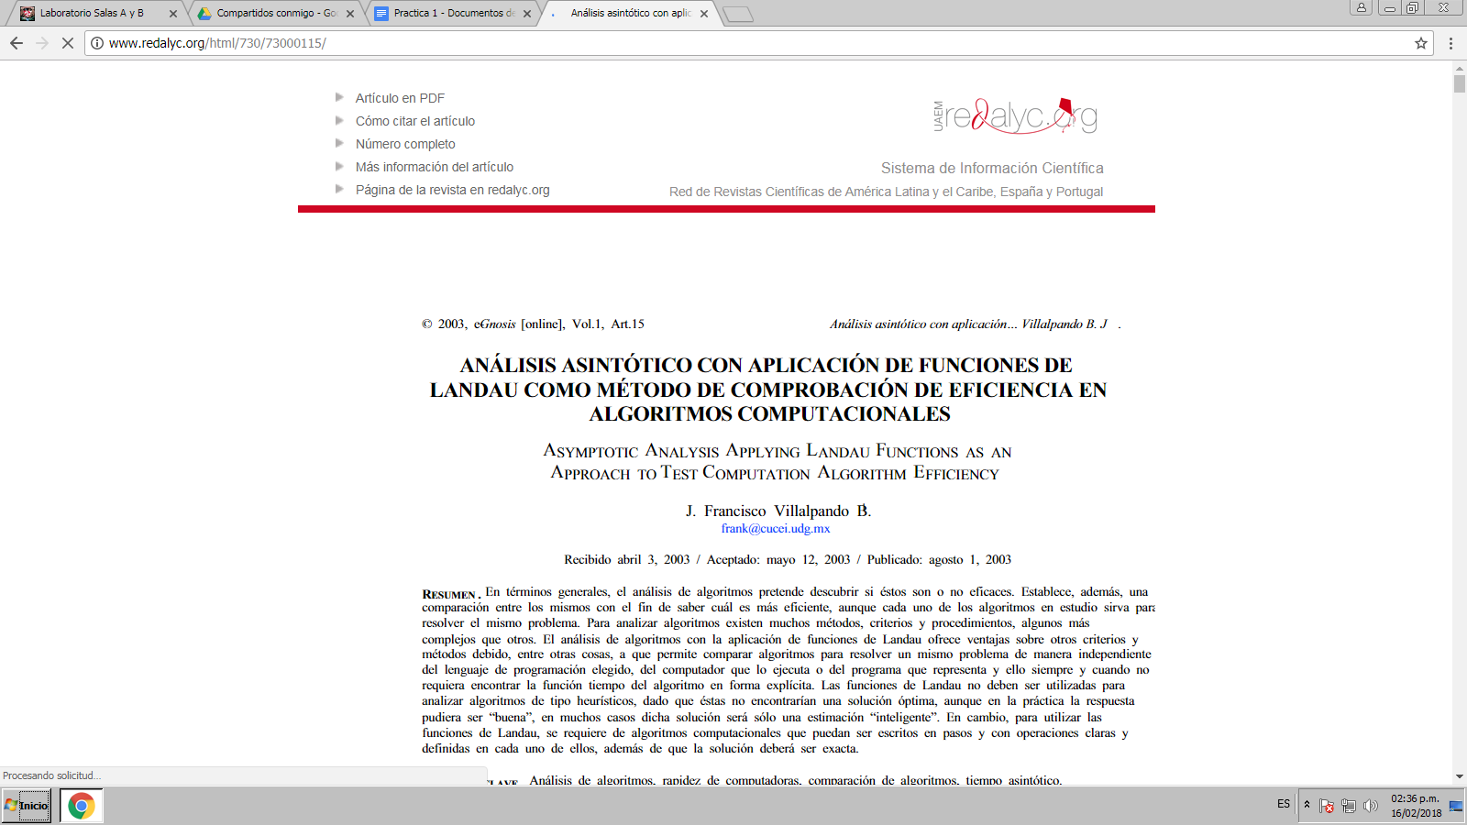

[**https://revistas.udistrital.edu.co/ojs/index.php/REDES/article/view/7173**](https://revistas.udistrital.edu.co/ojs/index.php/REDES/article/view/7173)

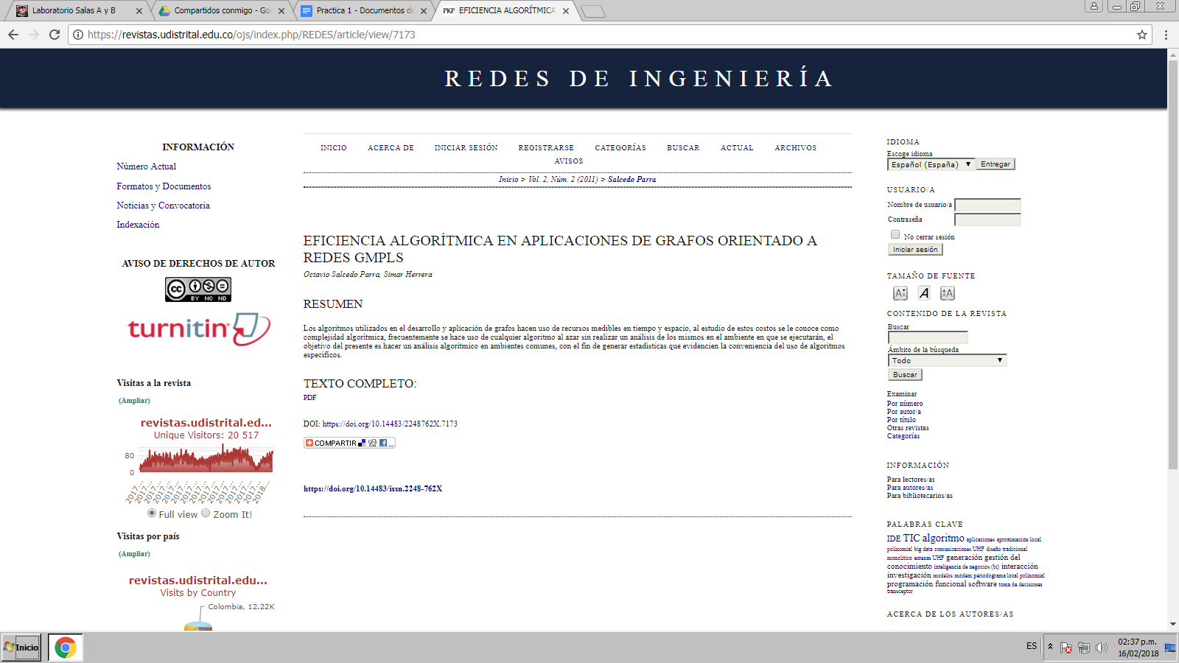

[**http://www.bdigital.unal.edu.co/52392/**](http://www.bdigital.unal.edu.co/52392/)

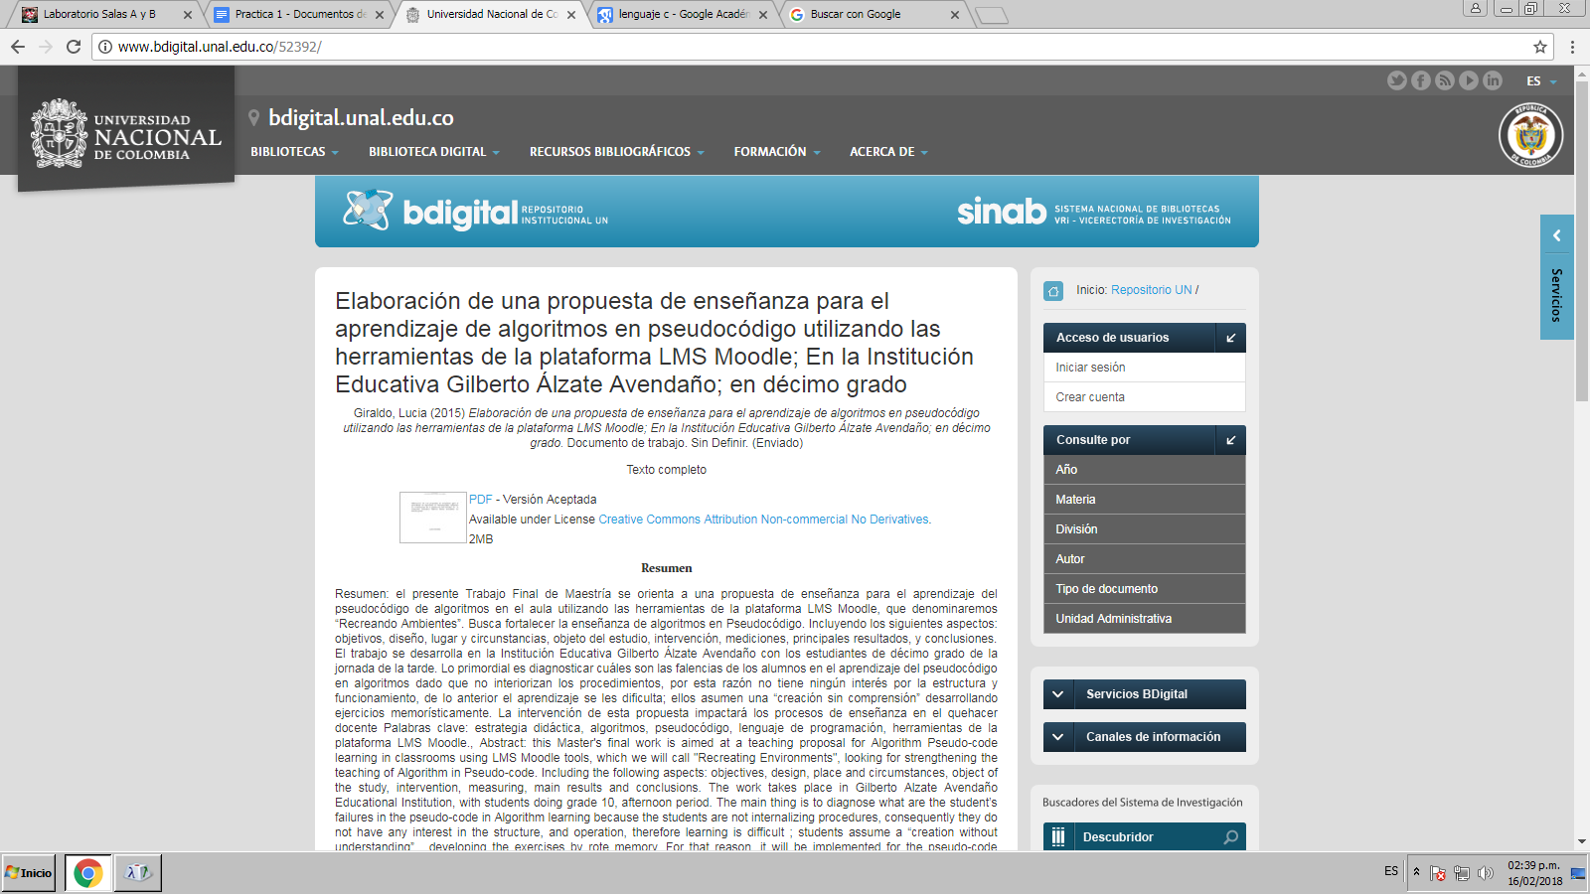

**LENGUAJE C**

<https://books.google.com.mx/books?hl=es&lr=&id=OpJ_0zpF7jIC&oi=fnd&pg=PR10&dq=lenguaje+c+ejemplos&ots=2cH4fjAjLZ&sig=2RPfFEJ3be3M0liqW5OZxKTdXLY#v=onepage&q=lenguaje%20c%20ejemplos&f=false>

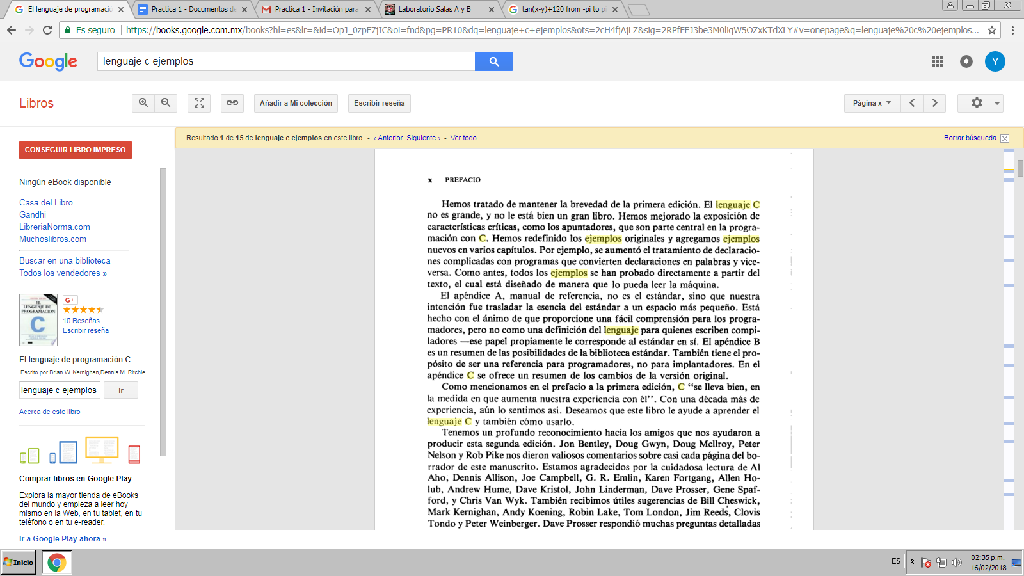

<https://es.slideshare.net/diwal10/pilas-colas-y-listas-estructura-de-datos>

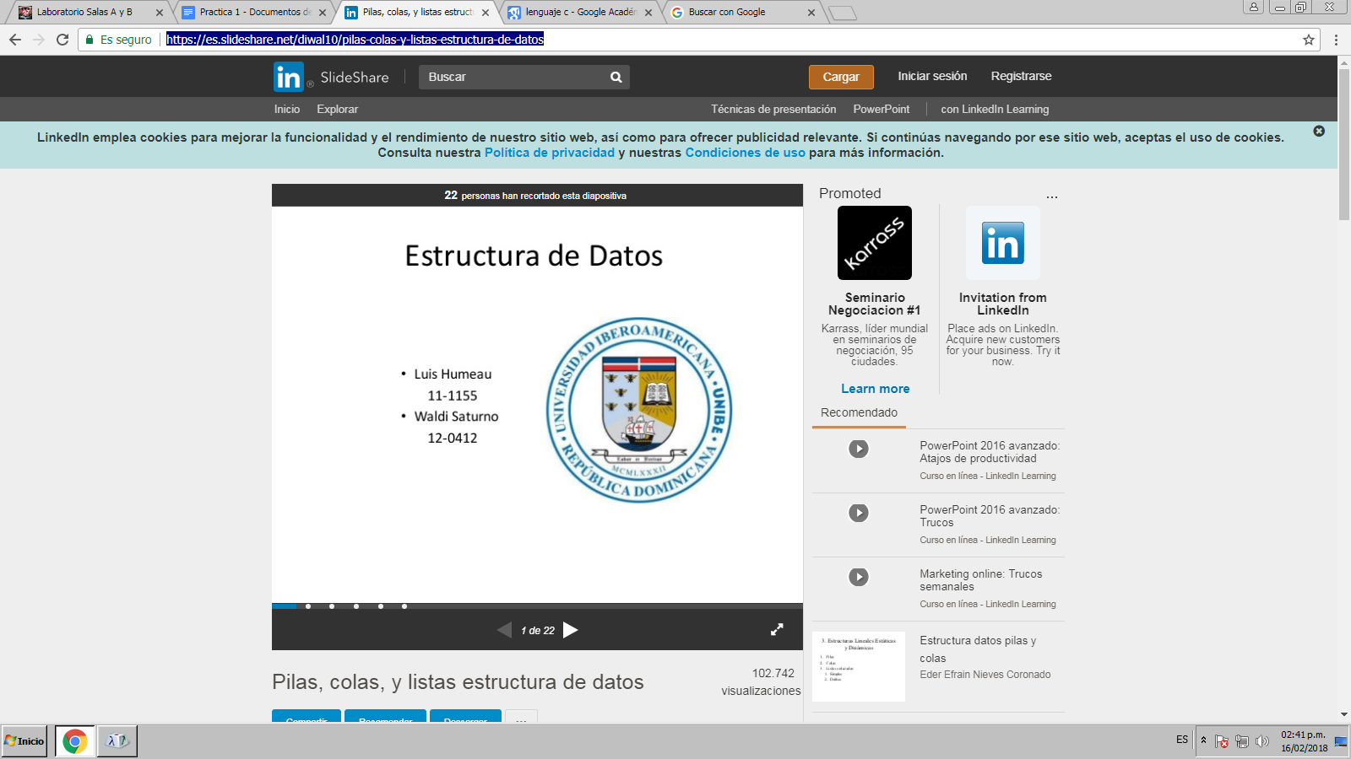

González Cabrera Rodolfo

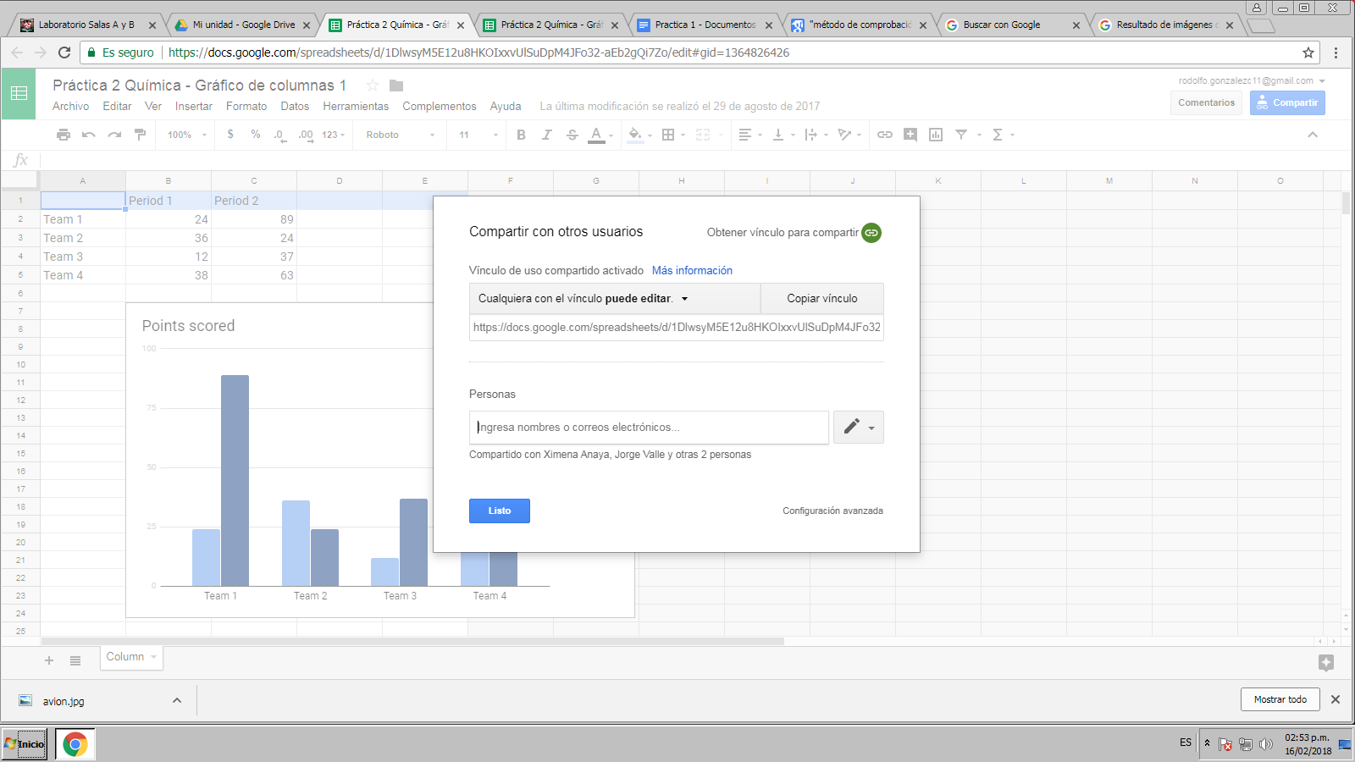

**Anaya Rodríguez Ximena**

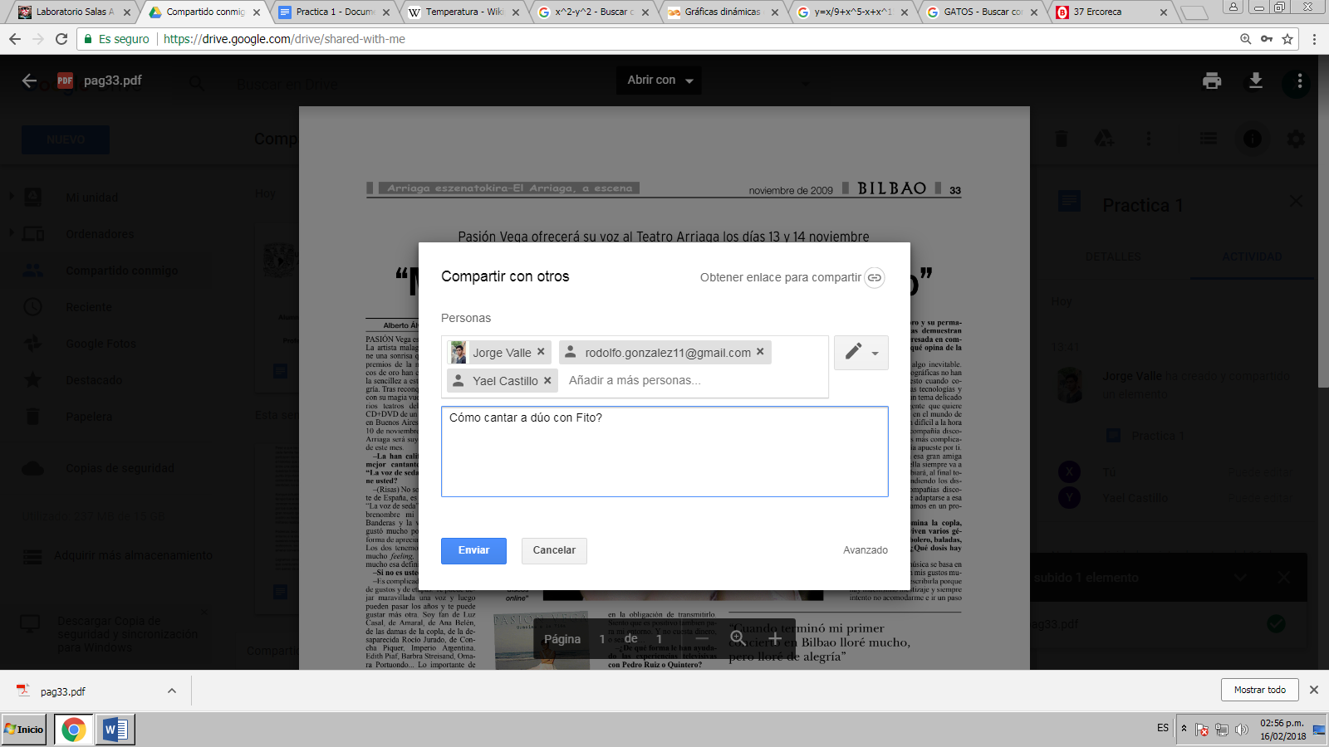

[**https://drive.google.com/drive/shared-with-me**](https://drive.google.com/drive/shared-with-me)

**Gonzalez Castillo Yael Adair**

